Project Template: Life Cycle Assessment (LCA) with University Products
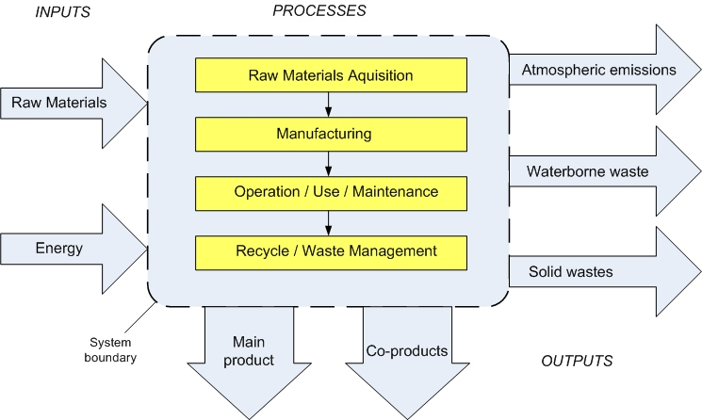
This template is designed for a broad range of skillsets and skill levels and proposes a few options for projects. These may be scaled up or down based on whether the endeavor is a group or individual project, or on time constraints.
All projects will begin by selecting a commonly used product at the school. Whether a comparison is useful for the analysis is up to the student and/or instructor.
Standalone LCAs can yield important information on the degree and nature of impact, where along the supply chain the greatest points of environmental impact are, and aid in the identification of improvements.
You might choose a Comparative LCA if the aim of your project is to communicate how the current product fares against an alternative. If you are looking to prepare a report on which product the school should be using, this approach will likely be more helpful.
It is possible that the results for your LCAs do not provide a clear answer on which product is more environmentally friendly or preferable overall. For example, you may discover one product uses more energy, while its alternative relies on a greater quantity of scarce raw materials. Or, one product has a significant impact in the manufacturing stage while another is more costly in its use and maintenance stages. Regardless of what you find, remember that LCA is a process/tool among many to consider along your way to making your decision, whatever it might be.
One advantage of an LCA that you might want to consider is that it lends itself well to goal setting and attainment. Say, for example, you prepare an LCA for a department of the school that has decided it wants to reduce its overall waste stream and prioritize recycling. This group might look at two comparable products and opt for the one with less overall impact in its Operations/Use/Maintenance stage AND the Recycle/Waste Management stage; a longer lasting product (not requiring fast replacement) with a high percentage of component parts that can be recycled is likely to be chosen for this group.
Ethical presentation of results is important. In whatever form your final report takes, take care to provide as full of a picture of your data as possible. Where there are limitations, make sure you indicate them. If you decided to “prioritize” specific environmental impacts or stages over others, discuss why you did and review how that may impact your results.
Suggestions for products include:
- Wipes used at the Campus Recreation & Wellness Center
  - Compare with impact of disinfectant spray bottle and towel
- Paper or plastic cups used by the school
  - Compare with glass/reusable dishware
- Computers and monitors
  - Compare with different brands computer/monitor
- Air conditioning systems
- Desks, Chairs, Dry Erase/Chalkboards
- Housing and Dining Purchases?
There are a few routes available:
- Learning LCA Without Software
Step 1. Research the inputs required for material acquisition and manufacturing. How much energy does it take to get the materials required for your product and get the product made?
(If there are too many component parts to a product, select the most significant parts [if there is a small screw, it’s probably OK to exclude this for simplicity.] Document your sources throughout.)
Step 2. Research the energy requirements and raw material used for the product in its operation, use, and maintenance stages. Try to keep the quantified variable the same throughout.
Step 3. What’s the energy/raw materials input for recycling and waste management of your product?
Step 4. What are the emissions in the raw materials acquisition stage? (Use criteria air pollutants and GHG) What are the impacts to water quality (waterborne waste, associated pollution, etc.)? What about solid waste generation, if applicable?
Step 5-7. Repeat step 4 for the manufacturing, operation-use-maintenance, and waste management stage.
Step 8. Identify main product and possible coproducts. Compare environmental impacts across stages, sum overall impacts or present all impacts (if different units).
- Learning LCA With Software
Run your analysis using OpenLCA or SimaPro software. The results for these should be more thorough and precise than Example I but will come with their own set of tradeoffs. Here, part of the assessment may have to do with the quality of the modelling/detail in the LCA performed in the software. Still, overall critiques and reports on findings/conclusions as specified in the deliverables should accompany the results.
- Analyzing Existing LCAs
Utilize Google Scholar, Infohawk, or existing databases of LCAs to pick a product of interest to you. If you choose a single product to analyze pick at least two LCAs about the product and compare their results. If you choose to compare between two products, survey LCAs about each of the two and compare overall environmental performance. Write a report as indicated below.
Possible Deliverables and Outcomes
- A written report reflecting on the strengths and weaknesses of LCA, a summary of findings on your product(s) (is there a preferable one? Are they preferable by different metrics?), conclusions, limitations of results and recommendations for future study.
- Relevant outputs from running LCA(s) on SimaPro or OpenLCA software, or tables from independent study.
- A mock presentation and/or report to the relevant department or Office of Sustainability and the Environment on findings, recommendations.

